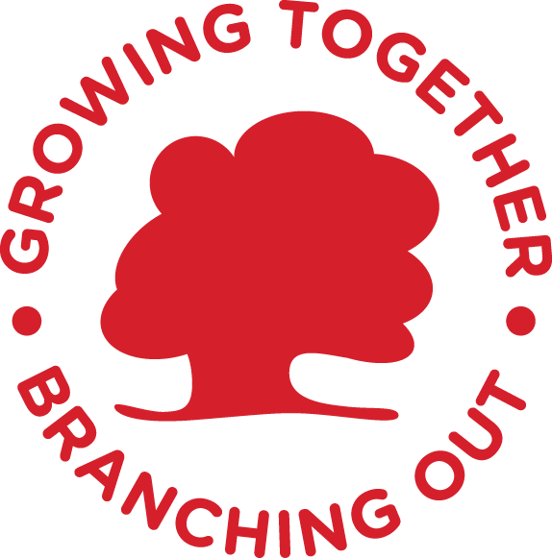

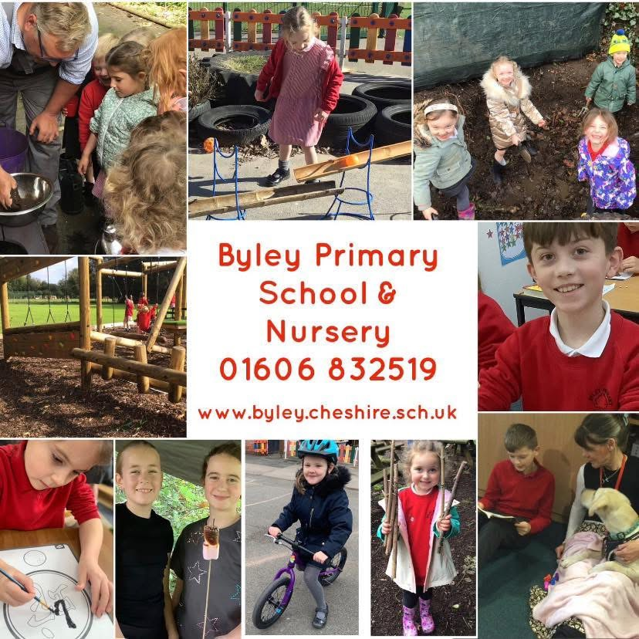

Prospectus
website: www.byley.cheshire.sch.uk

INTRODUCTION
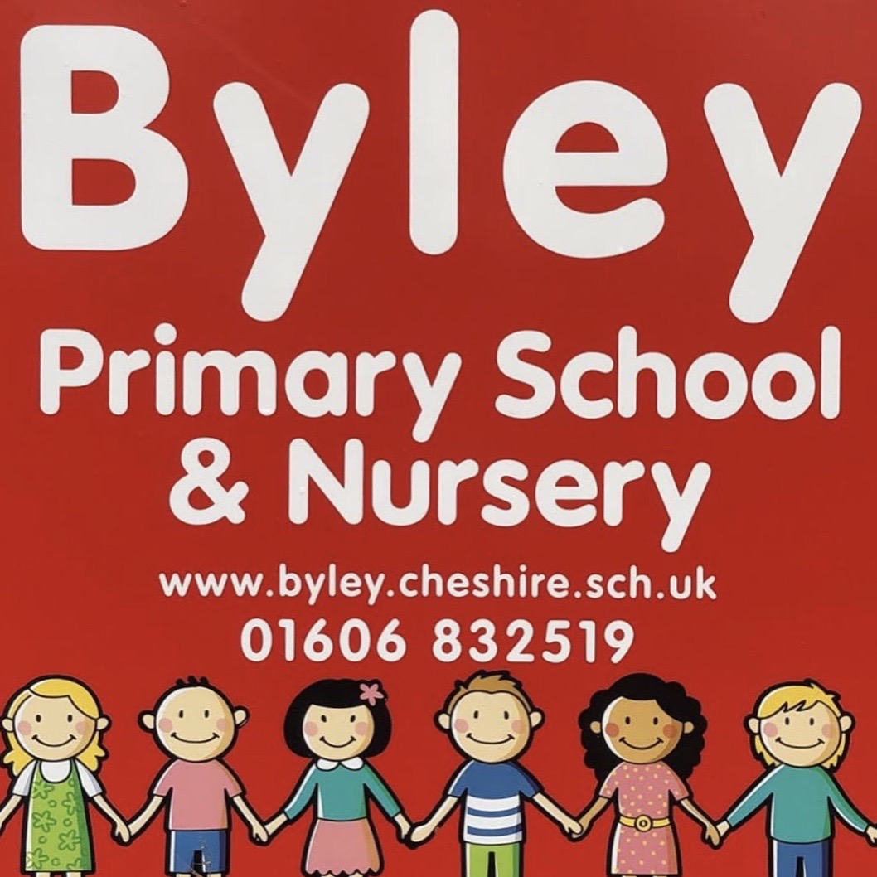
Our School Prospectus is intended to give you information about
our school.

Children at Byley Primary School are confident, cooperative and independent learners who feel safe and are happy in their surroundings.
‘Pupils thrive in the calm and nurturing atmosphere that leaders and staff have created. (Ofsted 2023)
That we become the best that we can be is at the heart of our philosophy. There is a true sense of family and community here; we work in close partnerships with families to encourage and support the children in every aspect of their learning. ‘The children explained that their school ‘is like a family because everyone cares for each other.’ (Ofsted 2023)
Class sizes are small and children are treated as individuals who quickly develop social skills; building relationships with children and adults whilst being sensitive to the needs of each other. Children all enjoy school and feel good about themselves, taking a pride in their achievements. ‘Pupils enjoy their lessons. They are eager to learn. Pupils behave well and work hard.’ (Ofsted 2023).
We offer an engaging curriculum which is researched and delivered by an experienced staff of highly committed, caring professionals. We share high expectations and provide excellent learning opportunities inside and outside the classroom - including enrichment activities available through our close links with partner primary and secondary schools. Children’s learning is carefully planned for and assessed, enabling all pupils to succeed.
We aim to inspire, motivate and challenge all children to develop a life-long love of learning. Byley pupils aim to achieve high standards in all areas of school life; they are motivated to be creative, innovative and sporting. We encourage young people to have positive values and a strong sense of right and wrong.
Our school environment is safe, nurturing and stimulating. Lessons are fun, exciting and purposeful; inclusive of all children.
We have an active PTA which organizes a variety of fund-raising events throughout the year to benefit our children. New members are always welcome.
We currently offer a Breakfast Club from 7:45am each morning and an After-school Club from 3:20pm – 6:00pm each day.This is bookable in advance and very reasonably priced.
Our Governors play an important part in the running of the school. They meet formally once each term and endeavour to attend school functions and events.
We welcome prospective parents to visit our school. We hold an annual open day and evening in the Autumn Term. If you would like to visit us and discuss your child’s education at another time, I will be very pleased to meet you and show you round. Please telephone - 01606 832519 or email – admin@byley.cheshire.sch.uk to make an appointment.
Elizabeth Whittingham (Head teacher)

ADMISSION TO SCHOOL
Nursery and Reception
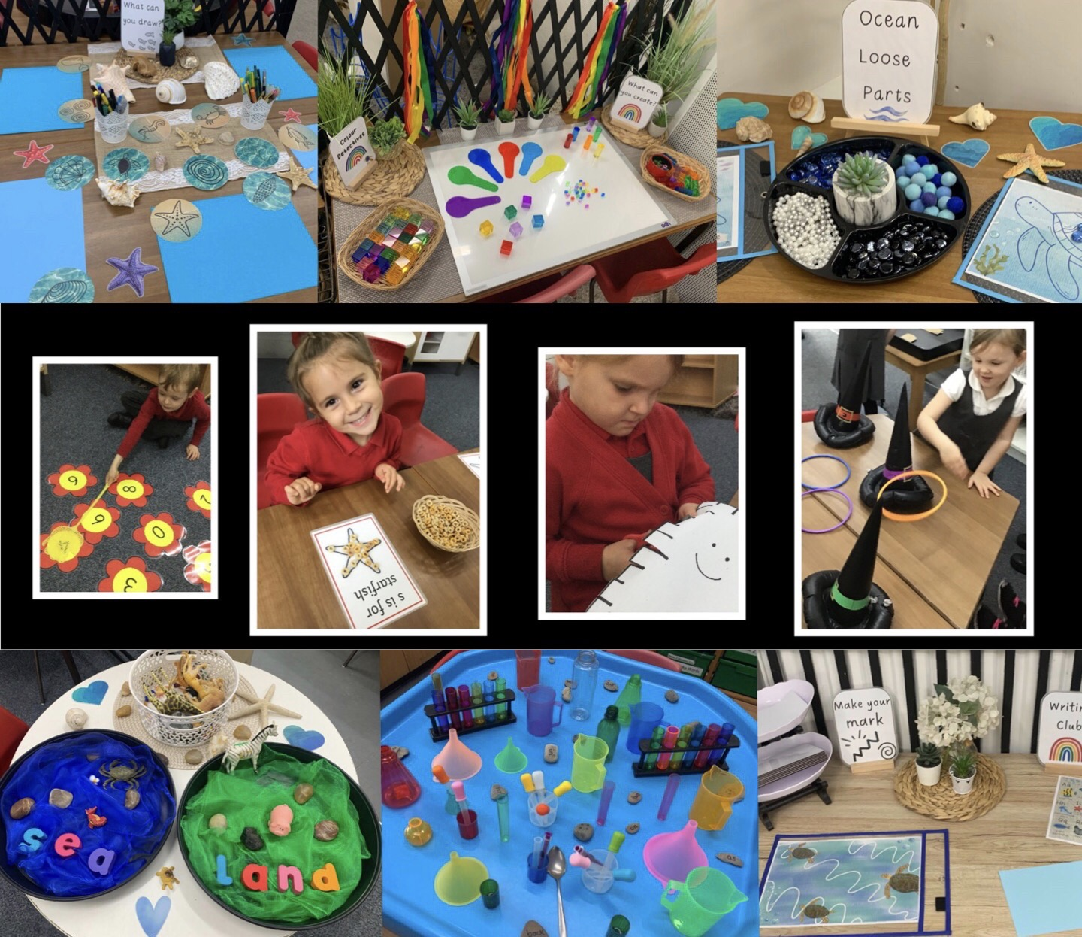

It is important to us that parents and teachers work together to ensure that your child’s development is successful.
We take children from the age of 3 into our nurturing EYFS class.These children qualify for 30 hours funded nursery provision each week from the term following their 3rd birthday. Alternatively, your child can start school in the September after their 4th birthday.
Our school is in the Cheshire West and Chester Local Authority but we admit children from both Cheshire West and Cheshire East Local Authorities. If you live in Cheshire East and wish to apply for a place for your child at Byley, you can do so on the Cheshire East application form. You will find the Cheshire West and Chester Local Authority in the ‘drop down’ menu on the applications form. Selecting this option will enable you to apply for a place. Further details about our school and the admission process can be found on our school website http://byleyprimary.schools.uk.com
If you have any queries regarding the admission of your child to our school, please contact us.
The transition from home to school is helped considerably if children, who do not already attend our Nursery, join the Reception class for two half days during the summer term prior to their September start. These days are arranged by school. Parents are informed of the dates in advance.
PARENTS are the most important people in their children's lives. We need and welcome your support, encouragement and interest in our school.
We have formal occasions for discussing your child's development with you. There is no need to wait for these if you have any worry or concern. Come to us straight away. Parents are always welcome in school and we always do our best to resolve any worries you may have.

EARLY YEARS

How you can help prepare your child for school:

The following suggestions help you prepare your child for school in the most effective way.

- Read and talk about stories as often as possible so that your child associates reading with pleasure

- Help your child to hold a pencil correctly, i.e. between thumb and forefinger and supported by the second finger

- Teach him/her to undress/dress with minimum help in indoor and outdoor clothes. Although we are always ready to help, this does save time within the school day

- Make sure that he/she can use the toilet without help

- Mark articles of clothing with his/her name to encourage him/her to take responsibility for his/her own belongings

How you can help once your child has started school:

- Continue to read as many stories as often as possible letting children talk about the pictures and stories

- Show an interest in what he/she does at school; praising what he/she can do and
has learned

- Help with number work by counting and playing number games

- Help with writing, by encouraging correct letter formation - reinforcing the work that will be done in school. Mrs Madden will be happy to advise you about the way we teach letter formation in school

Home-School Agreement

During you child’s first term in school you will be asked to sign a copy of our Home-School Agreement.

These Agreements have been drawn up as part of a Government initiative to formalise the relationship between Parents/Carers, pupils and schools. Our Agreement was produced in consultation with staff, pupils and our Governing Body and refers specifically to Byley Primary School & Nursery.

Copies of the Agreement will be sent home before the October half-term break, after your child has had time to settle into school and to become familiar with our rules and routines.

AIMS OF THE SCHOOL

We believe our school should aim to:

- Achieve the fullest possible personal development and enrichment for each child in all strands of life - social, physical, spiritual, emotional and intellectual

- Create an environment which gives access to the linguistic, mathematical, scientific, artistic and creative skills of our culture and of other world-wide cultures

- Use our knowledge of the way in which children develop intellectually to facilitate learning with understanding. This is best achieved by teaching from first-hand experience where possible, and allowing children to acquire knowledge and skills through problem solving situations

- Encourage personal enjoyment in learning by equipping children with skills of observation, recording and independent appraisal of sources of information

- Foster enjoyment and pride in maintaining high standards of work presentation by providing an environment rich in attractive and stimulating equipment, books, materials and displays of work

- Provide a thoughtful and caring atmosphere in which relationships are based on mutual respect. The importance of consideration for other people, their work and achievements and their property is an integral part of the ethos of the school

- Encourage the development of self-discipline by giving some controlled responsibility in planning work and organisation of time

- Foster sensitivity and creativity of thought, speech and action in all aspects of life, and to help children to achieve a deep sense of enjoyment in their work
CLASS ORGANISATION

Our children are organised into four classes:
EYFS (Nursery & Reception), Years 1/2, Years 3/4, Years 5/6.

The Primary National Curriculum recognises that children should be offered a curriculum which is balanced and broadly based and which:
- promotes the spiritual, moral, cultural, mental and physical development of pupils at the school an of society, and
- prepares pupils for the opportunities, responsibilities and experiences of later life.
Curriculum 2014

We recognise that children vary in their development and need programmes of study which take account of individual progress. Our Schemes of Work are based on these programmes of study and are structured in the form of ‘rolling programmes’ to take account of the needs of our mixed age classes.
Schemes of work are adapted appropriately for all learners, including those with statements of Special Educational Needs. If parents require further information, please contact the school for advice.

Teaching is organised in a flexible way to allow for these individual needs. Children may work in small groups or individually, depending on the work they are doing at the time. We pay great attention to problem-solving activities which encourage children to think independently and develop self-motivation. Formal class teaching also has its place in encouraging children and giving direction to their work.

The school has a policy of using its resources to employ specialist teachers from time to time to work with the children in school so that they can benefit from special expertise in a particular area. This has the advantage of introducing the children to a wider range of adults in school within the framework of the village school atmosphere. Parents and other interested adults are also welcomed as helpers and play a valuable part in the education of the children.

Assemblies take place most days in our school hall. They are broadly Christian based but also join the school together to celebrate achievements - as well as encouraging positive relationships and tolerance of others. They are led by the Headteacher, a member of teaching staff, a member of the local clergy or a representative of the local community.
Religious Education is taught in accordance with the Local Authority guidelines. Parents have the right to withdraw their children from these lessons and from the daily school assemblies.

We run a variety of after/before school sports clubs throughout the year for children from Year 1 onwards. There is no charge for these activities.

We organise Residential visits for children in Years 3/4 and Years 5/6. The younger children attend for 2 days, with 1 night away; the older children for 3 days and 2 nights. As well as providing a range of rich and varied activities, these also help to prepare and encourage children to become increasingly independent and confident.
ATTENDANCE

The school day

8:40 – 8:50 – Children should arrive in school
9:00 – Lessons begin
12:00 – 1:00 – Lunchtime
3:00 – Nursery day ends
3:20 – School day ends

All children have a morning break.
KS1 have a scheduled afternoon break.

Absence
It is important that parents always contact school by telephone or in person on the morning of the first day of absence and any subsequent days.

Following changes in legislation, which came into force in September 2013, pupils are no longer allowed to take holidays during term time unless there are exceptional circumstances. At present, permitted ‘exceptional circumstances’ are:
- When a parent who is in the Armed Forces returns from a tour of duty abroad;
- To allow family time prior to and following the death of a very close relative;
- Life threatening and life limiting illness of a child or sibling;
- Visit abroad prior to a family moving there.
Any other absences for holiday will be unauthorised and may result in parents being issued with a Fixed Penalty Notice and a fine by the Local Authority. We are informed by and follow the most up-to-date guidance that came into force on August 19th 2024

https://www.gov.uk/government/publications/working-together-to-improve-school-attendance
INCLUSION

At Byley Primary School & Nursery we are fully committed to providing an inclusive education for all our pupils in all areas of the curriculum and school life.

Children with Special Educational Needs and Disabilities (SEND) are given as much support as possible from the class teacher and Special Needs Co-ordinator. Work is planned to suit individual abilities. When the child's needs require more support than this, the LA’s Learning Support Service is usually consulted for advice and additional support following consultation with parents.
All procedures relating to children with SEND fulfil the requirements of the Department for Education’s Code of Practice.

DISCIPLINE

The class teachers or Head teacher deal with school discipline in most instances. If more serious or persistent behaviour problems occur, parents will be contacted and invited to discuss the problem with staff to discuss next steps and a suitable course of action.

SAFEGUARDING

At Byley Primary School & Nursery we take our duty of care towards our pupils very seriously.
All members of staff are kept fully informed about child protection procedures through staff meetings, designated training and by having access to relevant documents and information.
Our Safeguarding Governor is Mrs D Brain. She can be contacted, if required, through school.
We also ensure our pupils are made aware of relevant information through, for example, teaching sessions, class and group discussions, visitors to school, posters and newsletter items.

COMPLAINTS

If you have a concern, this should be discussed initially with your child’s class teacher or the Headteacher.

If the problem can’t be resolved, parents/carers should follow the procedures outlined in the Complaints Precedure Policy – available on the school website. A printed copy can be obtained from the School Office if neeed.
Our Chair of Governors is Mr A Gibson. He can be contacted via school or you can e-mail: chair@byley.cheshire.sch.uk

RELATIONSHIPS AND SEX EDUCATION (RSE)

Children may raise questions about sex in response to health education topics or the Science Curriculum. Staff will always do their best to answer questions as sensitively as possible, bearing in mind the age and development of the children concerned. Alternatively, parents may be consulted first if this is more appropriate. We also arrange for a health professional to talk with children in Years 5 and 6. Parents may, if they prefer, withdraw their child from this lesson.

COMMUNICATION WITH PARENTS

We use various methods of communication with parents and carers. Our most widely used method of communication is our weekly Newsletter which is emailed out every Friday during term time. Newsletters are also available on our website.
The children in Reception are sent a weekly newsletter from their teacher every Friday, outlining the work they have done during the week and explaining what they will be doing during the following week.

The children in Years 1 to 6 have their Curriculum published on the school’s website.

Additional information is sent to parents when necessary.

Our school website is also an effective means of communication with parents. Teaching staff and Mrs Evans, our Bursar, update the website regularly. Our website contains a host of information for families including: holiday dates, relevant policies, school meals information and on-line copies of the Newsletters.

Parent Consultation Meetings are held in the Autumn and Spring Terms. Parents/carers have the opportunity to discuss their child’s progress with the class teacher. Annual reports are sent to parents at the end of the school year.

Our Open Afternoon/Evening in the Autumn Term provides an opportunity for existing and prospective parents to visit and see our school and pupils in action. We also hold an Induction afternoon for parents of our September intake in June.

We operate an ‘open door’ policy where the class teachers are available on the playground at the end of the school day to liaise with parents and carers. Miss Whittingham is also available to speak to parents at either end of the school dday. If you are unable to come into school immediately to discuss any concerns we can usually arrange a mutually convenient time for you to do so.

SCHOOL MEALS
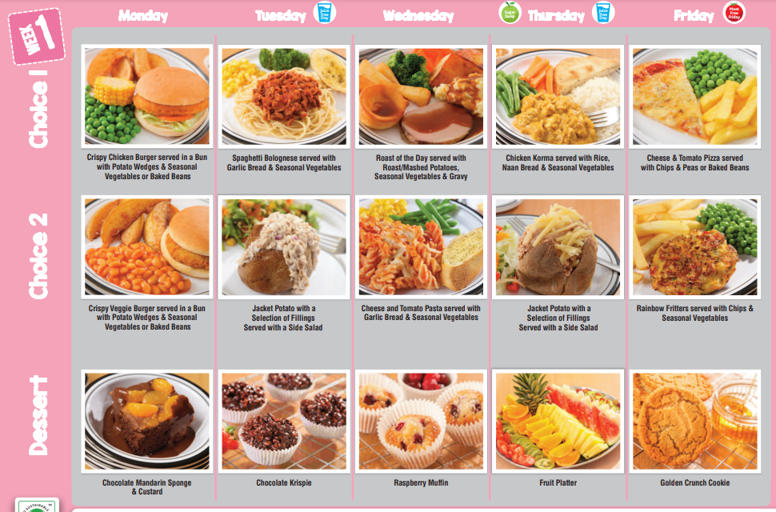
Our children can have a hot school meal
every day or can choose to have hot meals
on Wednesdays and Fridays.
Payments are made via the online ‘Parentpay’
system. No money for school dinners should be
sent in to school.
A school dinner currently costs £2.95.
Dinner money should be paid in advance via
ParentPay. Children in Early Years and KS1 are
entitled to free school dinners.
There is provision for children to bring packed lunches, if preferred.

If you feel your child may be eligible for free school meals, please speak to Mrs Evans, our Bursar, and she will be able to give you the necessary information.
As part of our healthy school initiative, children are encouraged to bring only fresh fruit or vegetables as a mid-morning snack. Crisps, chocolate, sweets and other sugary snacks are not permitted at break time. The children have free access to fresh drinking water during the day. Each child has a school water bottle which they bring into school each day, filled with fresh water. This can be topped up if needed from our water cooler. We ask that pupils who have packed lunches do not bring cans or bottles of fizzy drinks.

SCHOOL UNIFORM

Our school uniform is:

- white or red polo shirt (with or without school logo)
- red sweatshirt, jumper or cardigan (with or without school logo)
- red school fleece - optional (for outside)
- grey trousers, shorts, skirt or pinafore (or red and white checked summer dress)
- plain grey, black or white socks
- plain black shoes or plain black trainers

You can purchase items with the school logo from ‘Clever Clogs’ in Middlewich.
Non-logo items can be bought from many shops and are just as acceptable.

Please ensure all items of uniform are clearly named – including coats.

We have a good selection of very good quality ‘pre-loved’ uniform in school. If there are any items you require, please ask a member of staff.

We would be grateful if you could provide your child with a small bag to hold reading books and homework. Bags bearing the school logo are available in school, priced £5.
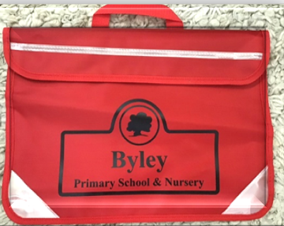

PHYSICAL EDUCATION
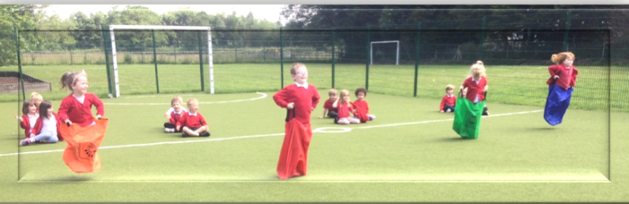

Indoor PE lessons take place in the school hall. Outdoor games are played on our school field, the playground or MUGA..

Children should wear the following PE kit:
- white t-shirt (with or without school logo)
- navy or black plain shorts/skort, plain dark leggings or jogging bottoms (to wear over shorts if the weather is cold)
- trainers – with Velcro fastening if your child is unable to tie their own laces (these do not need to be black trainers)
- red school sweatshirt (plus a plain hoodie to go over the top if the weather is cold)

PE kit should be kept in a clearly named drawstring bag.

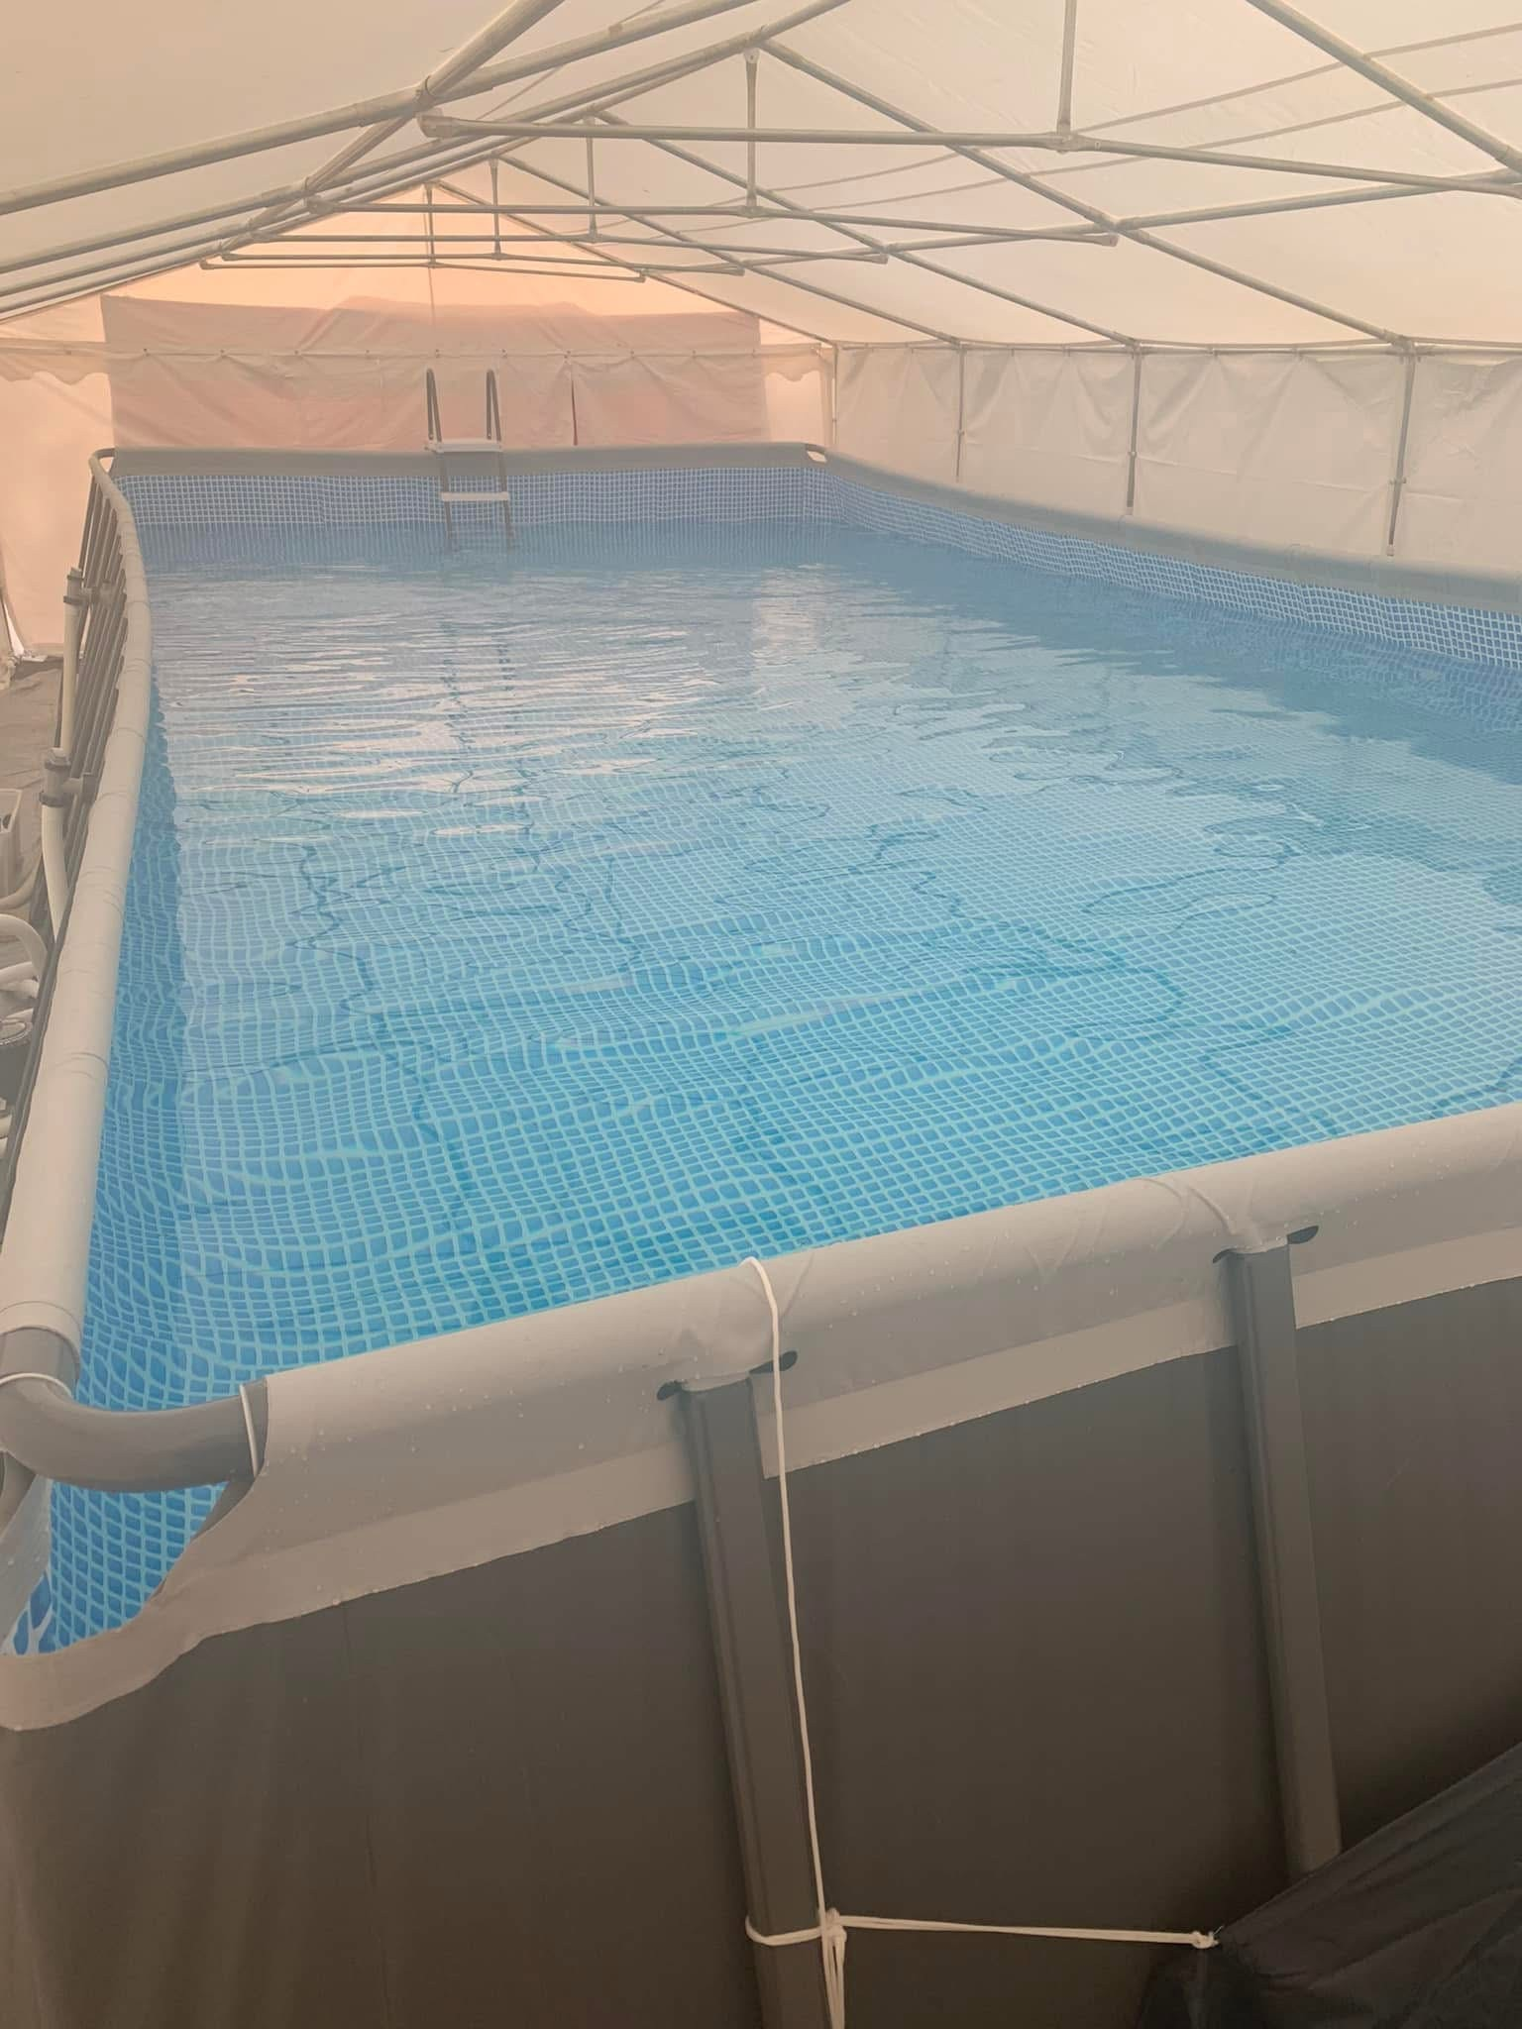
Please note that ‘fashion’ items of PE kit such as crop tops and brightly printed leggings should be avoided. Football kits are also not acceptable.

During P.E. and swimming lessons ear-rings must
be removed or covered with sticking plaster and
the children must be able to do this themselves
to comply with Health and Safety and
Child Protection guidance.

Daily swimming lessons are undertaken by
children from Year 2 (non-swimmers)
upwards in the swimming pool that is installed
on the school grounds for a 2 week period.

HOMEWORK

The amount of homework children are given depends upon the Year group they are in.

All children are expected to read/share a book each day. Children in Foundation Stage and Key Stage 1 take home books to read and discuss with their parents. They also have a reading diary where parents and teachers can exchange comments.

As children progress through the Key Stage they will be given Maths homework including times tables - which children need to learn by heart - and some spellings to learn.

In Key Stage 2 the children select library books to take home. They have spellings and multiplication tables to learn. The older children receive additional homework relating to work being done in English, Mathematics and other curriculum areas. The amount of homework given increases towards the end of Key Stage 2 in preparation for High School.

SECONDARY EDUCATION

Many of our Year 6 children make successful transitions to both Holmes Chapel Comprehensive School and Middlewich High School. Parents are able to apply for places at either school in accordance with Cheshire West and Chester Council and Cheshire East Council’s admissions policies.

SCHOOL CHARGING POLICY

You may sometimes be asked if you would be willing to make a voluntary contribution for special school activities, such as educational visits. However, your child will not be excluded from any activity if you are unable to make a contribution.

PTA

At Byley Primary School & Nursery, we are extremely fortunate to have an enthusiastic and committed PTA which all parents are very welcome to join. Our PTA has raised a considerable amount of money over the years, through a variety of activities for both children and parents. These have included summer fetes, cake sales and film nights, to name but a few.

The activities serve to bring all members of the school together as a community and the money raised has provided our pupils with a wide range of curriculum enhancing resources – for example new laptops and iPads.

The PTA is always looking for ways to enhance the provision for all children in the school and is a highly valued part of school life.

OTHER INFORMATION

The most up to date source of information about our school is our school website – http://byleyprimary.schools.uk.com where parents can usually find out most of the things they need to know about visits, events and other aspects of school life.
In addition, we have a noticeboard situated on the outside wall of our Reception classroom by the pedestrian entrance gate.

BYLEY PRIMARY SCHOOL & NURSERY

Teaching Organisation

In common with many schools our children are taught in mixed age and mixed ability classes.

Teaching staff:

Head teacher Miss E Whittingham

Nursery & Reception Mrs J Madden

Years 1 & 2 Mrs A King/Mrs H Bebbington

Years 3 & 4 Miss E Whittingham

Years 5 & 6 Miss A Shackleton

Teaching Assistants Mrs W Hampshire
Miss J Donaldson
Miss T Sobutta
Mrs H Bradbury
Miss L Williams
Mrs L Boyd (HLTA)

Non-teaching staff:

School Bursar Mrs C Evans

Caretaker/Forrest School Lead Mr E Smith

Catering Supervisor Mrs J Daniel

Mid-Day Assistants Mrs A Maddock
Mrs V Frith
Mrs H Bradbury

Byley Busy Buddies Miss C. Maddock
Mrs W. Hampshire
Mrs V Frith
Mrs A Maddock

Address: Moss Lane
Byley
Nr Middlewich
Cheshire CW10 9NG

E-mail: admin@byley.cheshire.sch.uk

Website: http://byleyprimary.schools.uk.com

Telephone/Fax: 01606 832519

SCHOOL GOVERNORS

The Governing body is made up of parents, teachers, local authority representatives and members of the local community. These people have responsibility for the management of the school, including: curriculum matters, management of finances, appointment of staff and maintenance of the school building. The Governors meet at least once a term but often more frequently, depending on the amount of business to discuss.

CHAIRMAN: Mr A Gibson Community

Vice-Chair: Mr J Beecroft Local Authority

Mrs D Brain Local Authority

Mr N Richmond Community

Mrs V Whiston Parent

Mrs S Ashton Parent

Mrs J Madden Staff

Mr E Smith Coopted

Mrs K Davies Coopted

Miss E Whittingham Head teacher

LENGTH OF SCHOOL DAY

KEY STAGE 2 (Years 3, 4, 5 and 6)

MORNING 8:50 a.m. - 12.00 noon 3 hrs 10 minutes

AFTERNOON 1:00 p.m. - 3.20 p.m. 2 hrs 20 minutes

Length of the school day is: 32.5 hours – in-line with Government guidance

EYFS and KEY STAGE 1
(EYFS, Years 1 and 2)

MORNING 8:50 a.m. - 12.00 noon 3 hrs 10 minutes

AFTERNOON 1.00 p.m. - 3.20 p.m. 2 hrs 20 minutes

Length of the school day is: 32.5 hours – in-line with Government guidance

NURSERY

MORNING 9:00 a.m. - 12.:00 noon 3 hrs

LUNCH 12:00 noon – 1:00 p.m. 1 hr

AFTERNOON 1:00 p.m. – 3:00 p.m. 2 hrs

30 hrs

